



**Module Code & Module Title**

**CC4057NT Introduction to Information Systems**

**Assessment Weightage & Type**

**30% Individual Coursework**

**Year and Semester**

**2021-22 Autumn 2**

**Student Name: Amshul Dhungel**

**Group: L1C3 A2**

**London Met ID: AMD0487**

**College ID: NP05CP4A210044**

**Assignment Due Date: 23st Jan 2022, 12:44 PM**

**Assignment Submission Date:**

*I confirm that I understand my coursework needs to be submitted online via Google Classroom under the  relevant module page before the deadline in order for my assignment to be accepted and marked. I am  fully aware that late submissions will be treated as non-submission and a marks of zero will be awarded.*

Contents

1. Introduction 1

2. Description of project 2

Objective: 2

Aim: 2

Tool and Technologies used for website: 3

HTML: 3

CSS: 4

JavaScript: 5

2. Wireframe: 6

Wireframe: homepage 6

Wireframe: book page (product page): 8

3. Testing 10

4. Conclusion 15

Bibliography 16

**List of Figures**

Figure 1 idea of web design 6

Figure 2 Wireframe of homepage 6

Figure 3 Actual home page 7

Figure 4: wireframe of product page 8

Figure 5: actual book pages or product page 9

Figure 6: hover effect 10

Figure 7: right arrow to go right 12

Figure 8: Reason for not-working slider. 13

Figure 9: JS function used 13

Figure 10: checking log in button 14

Figure 11: input username and password 14

**List of Table**

Table 1: Test 1 hover effect 10

Table 2: button working 10

Table 3: button working 11

Table 4: JS function for slider 12

Table 5: checking form and input 14

# 1. Introduction

The name of my website is Luffy Reader. This is an e-commerce website for a store that sells various books. The website is made focusing on teenagers’ interest that’s why various comics, manga and light novels are also available. There are different genres of books and two types of books. Fiction and non-fiction are two types of books which is in my websites. There are also interesting books for kids. In Nepal there should be children who are interested in comics and manga. So various new and exciting books for children are stored with latest comic. Adult can also have a fun in this website and buy books for their children and close one. There are also many self-help books which might interest some people if they are fond of law of attraction or something related to that.

So, for this coursework I was required to design and develop an e-commerce website for a store that sells various books. Through the coursework I should be able to demonstrate the following task:

1. Understanding of the basic Internet technologies and the impacts that the Internet has made in their daily lives.
2. Competency in designing a website with appropriate tools and technologies.
3. Capabilities of applying scripting languages to web pages.
4. Understand the structure of the website and simple navigation principles.
5. Awareness of website design considerations: e.g., usability and accessibility.

# 2. Description of project

As I was required to create an e-commerce website for a store that sells various books with at least 5 web pages, including a specific blog page for demonstrating how technology has affected them in their daily lives, I created an e-commerce website for a store that sells various books with at least 5 web pages, including a specific blog page for demonstrating how technology has affected them in their daily lives. As a result, I make five separate pages (Home, Books, Store, Blog, About us). I also need to include a part on research. The primary page of the website is located on the home page. I added a header, navigation bar, logos, bottom, body, and section on the main page. I've included numerous images of book covers in the section tag, which are also listed as best-selling books from the store. The website has a functional navigation bar that allows the user to browse to all of the webpage components.

There is also proper use of html tags such as title, meta, image, table, div, and form, and proper tag nesting should be implemented. Attributes and comments are used properly. Additionally, all of the code is appropriately formatted and structured. Despite the fact that I do not grasp the research element of the coursework. However, that portion is displayed to compare and contrast the components utilized by the student on their website with the website under investigation for study.

### Objective:

The primary goal of this project is for students to be able to comprehend basic internet technology as well as the effects that the internet has had on their daily lives. They should also be able to compete in web design utilizing relevant tools and technologies. As students go through their study, they will be able to create their own websites using HTML, CSS, and JavaScript. Students and users who are attempting to develop their own website will be able to comprehend the structure of websites as well as basic navigation bar or principles if this occurs. Students will be aware of the factors that go into website design, such as usability and accessibility

### Aim:

to design and develop an e-commerce website for a store that sells various books.

## Tool and Technologies used for website:

### HTML:

The most basic building component of the Web is HTML (Hyper Text Markup Language). It establishes the content's meaning and organization. Other technologies than HTML are commonly used to describe the appearance/presentation (CSS) or functionality/behavior (JS) of a web page (JavaScript).

"Hypertext" refers to the linkages that link online pages together, either within a single website or across multiple websites. The Web is built on the foundation of links. You become an active participant in the World Wide Web by uploading content to the Internet and linking it to pages established by others.

HTML annotates text, graphics, and other content for display in a Web browser using "markup." Special "elements" in HTML markup include head>, title>, body>, header>, footer>, article>, section>, p>, div>, span>, img>, aside>, audio>, canvas>, datalist>, details>, embed>, nav>, output>, progress>, video>, ul>, ol>, li>, and many more.

"Tags," which consist of the element name enclosed by "" and ">," separate HTML elements from other content in a page. An element's name inside a tag is case insensitive. It can be written in capital, lowercase, or a combination of both. The title> tag, for example, can be written as TITLE>, TITLE>, or any other variation

**So, what is Html?**

HTML is a markup language that specifies how your material is organized. HTML is made up of a set of elements that you may employ to enclose or wrap certain parts of your content to make it seem or perform a certain manner. The surrounding tags can be used to make a word or image hyperlink to another location, italicize words, change the font size, and so on. (developer, 2022)

The following are the primary components of our element:

1. 1.The element's name (in this case, p) is enclosed in opening and closing angle brackets in the opening tag. This specifies the point at which the element begins to take effect — in this case, the beginning of the paragraph.
2. The closing tag is identical to the opening tag except for the addition of a forward slash before the element name. This specifies the point at which the element — in this case, the paragraph — comes to an end. One of the most common novice mistakes is failing to add a closing tag, which might result in unexpected effects
3. One of the most common novice mistakes is failing to add a closing tag, which might result in unexpected effects
4. The following is the content: This is the element's content, which is merely text in this case.
5. The element is the opening tag, which is the first tag on the page.

### CSS:

CSS is a stylesheet language for describing the display of an HTML or XML page (including XML dialects such as SVG, MathML or XHTML). CSS specifies how items should be shown on a computer screen, on paper, in speech, or in other forms of media.

According to W3C guidelines, CSS is one of the basic languages of the open web and is standardized across Web browsers. Previously, distinct portions of the CSS specification were developed simultaneously, allowing for versioning of the most recent recommendations. You've probably heard about CSS1, CSS2.1, and CSS3. CSS4, on the other hand, has never been made an official version.

CSS is not a programming language like HTML. It's also not a markup language. CSS stands for Cascading Style Sheets. CSS is used to style HTML elements selectively. CSS (Cascading Style Sheets) is a programming language that is used to style web content. CSS fundamentals explains what you'll need to get started. We'll respond to questions such as, "How can I make text red?" How can I make content appear in a specific spot-on a (webpage) layout? How do I add background images and colors to my webpage?

### JavaScript:

JavaScript is a computer language that allows you to make your website more interactive. This occurs in games, in reaction behavior when buttons are touched or when data is entered on forms; in dynamic style; in animation, and so on. This tutorial will help you get started with JavaScript and expand your knowledge of what it can do.

JavaScript is a sophisticated computer language that may be used to make a website more interactive. Brendan Eich was the one who came up with the idea (co-founder of the Mozilla project, the Mozilla Foundation, and the Mozilla Corporation).

JavaScript is a beginner-friendly scripting language. You'll be able to make games, animated 2D and 3D visuals, database-driven apps, and much more as you gain experience. JavaScript is a small but powerful scripting language. On top of the core JavaScript language, developers have created a range of tools that unlock a great amount of capability with no effort.

These are some of them:

* Web browser APIs provide features such as dynamically constructing HTML and CSS styles, collecting and processing a video stream from a user's webcam, and generating 3D images and audio samples.
* Third-party APIs allow developers to integrate features from other content providers, such as Twitter or Facebook, into their own websites.
* Third-party frameworks and libraries that can be used with HTML to speed up the development of websites and applications.

# 2. Wireframe:

### Wireframe: homepage



Figure idea of web design

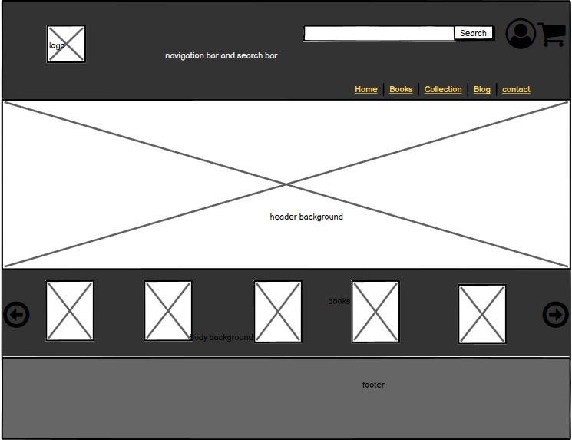

Figure Wireframe of homepage

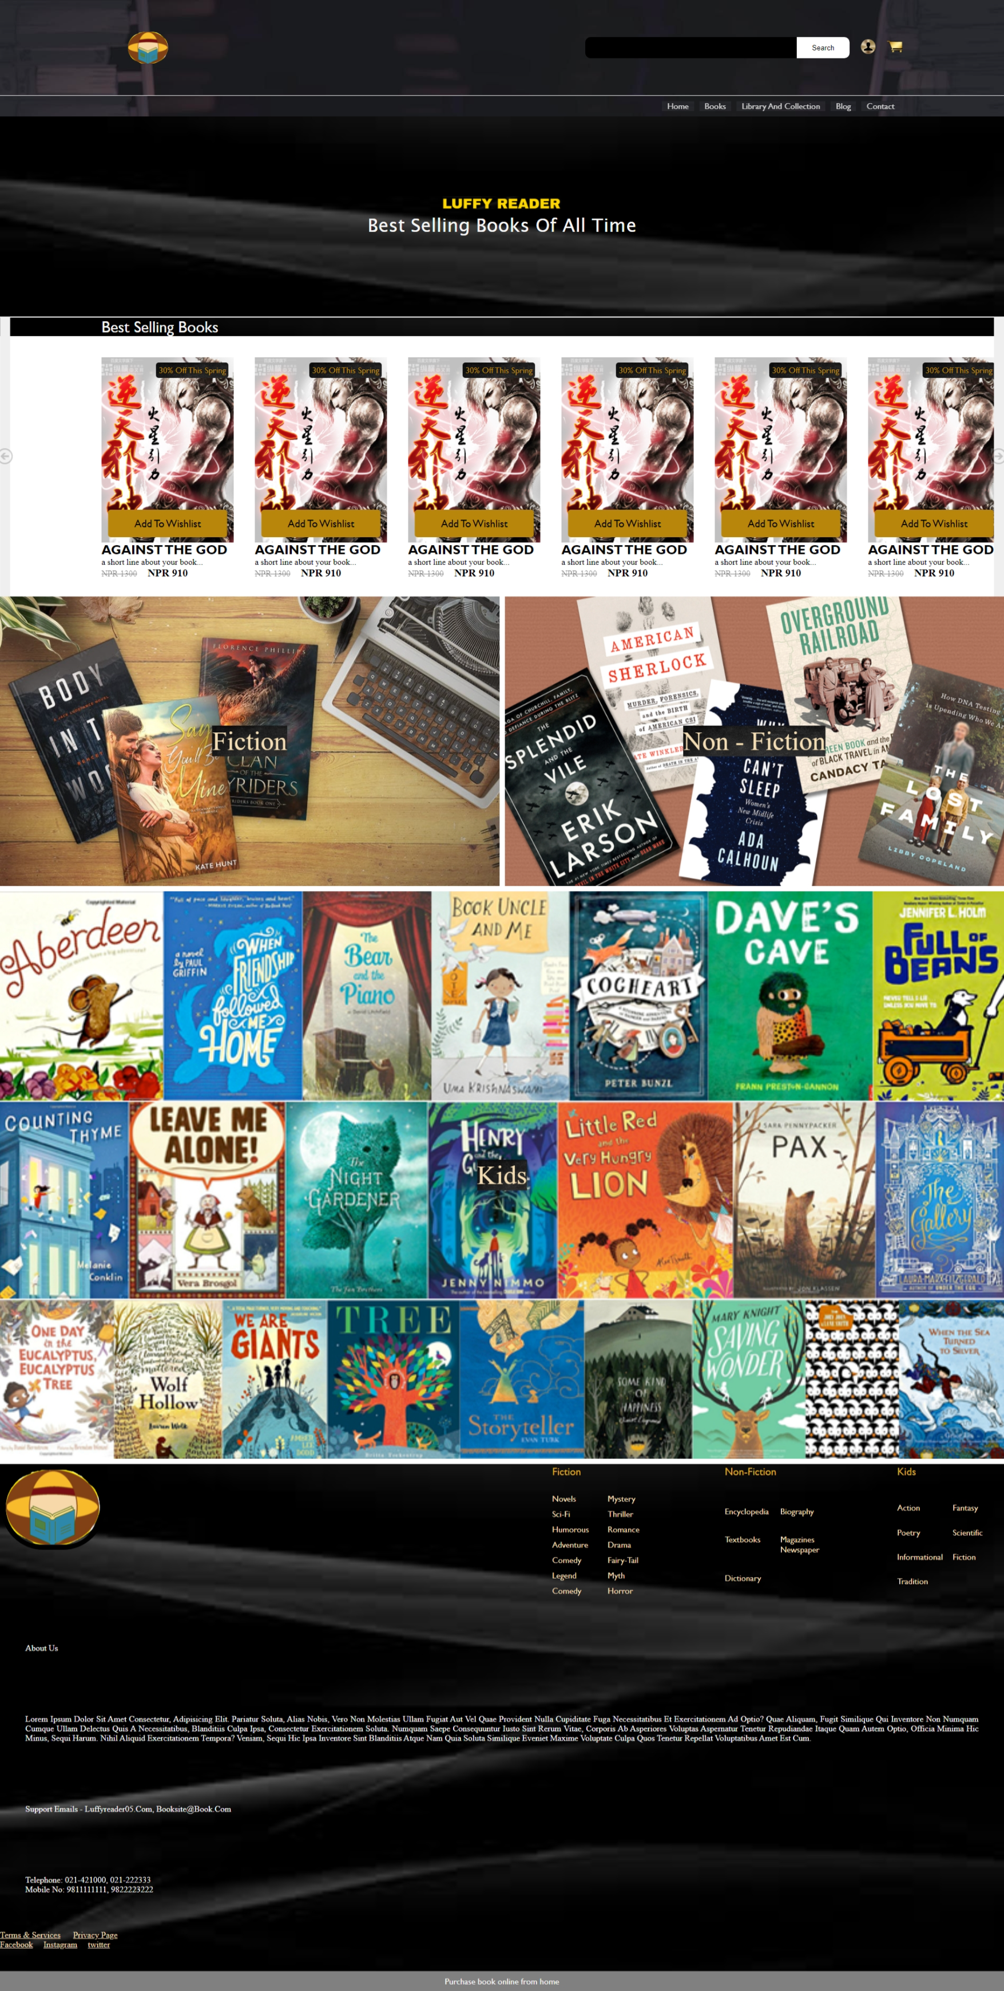

Figure Actual home page

### Wireframe: book page (product page):

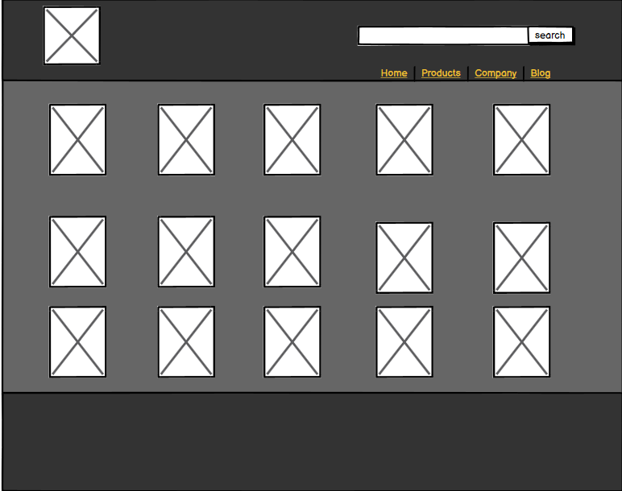

Figure : wireframe of product page

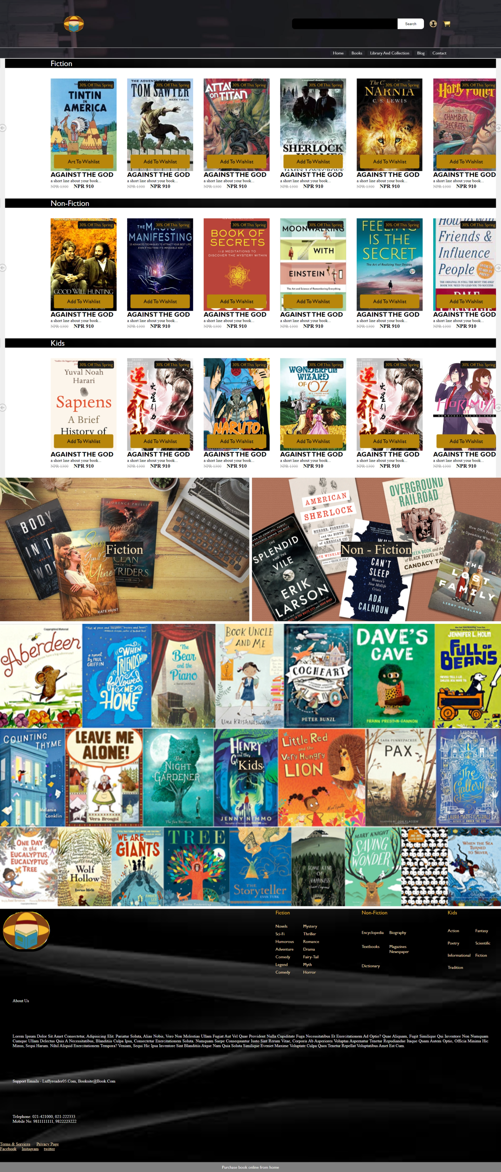

Figure : actual book pages or product page

# 3. Testing

|  |  |
| --- | --- |
| **Test Number** | **1** |
| Objective | Checking hover effect is properly done or not |
| Action | Putting cursor on the nav link |
| Expected Result | Should display border and white background |
| Actual Result | Displayed border and white background |
| Test result | Successful |

Table : Test 1 hover effect

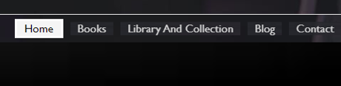

Figure : hover effect

|  |  |
| --- | --- |
| Test Number | 2 |
| Objective | To check whether button is clicking or working |
| Action | Click ‘add to Wishlist’ from book page. (not from home page) |
| Expected Result | Show button by displaying something like number or code at the top of the screen. |
| Actual Result | Showed button by displaying something like number or code at the top of the screen. |
| Test Result | Test successful |

Table :test 2 button working

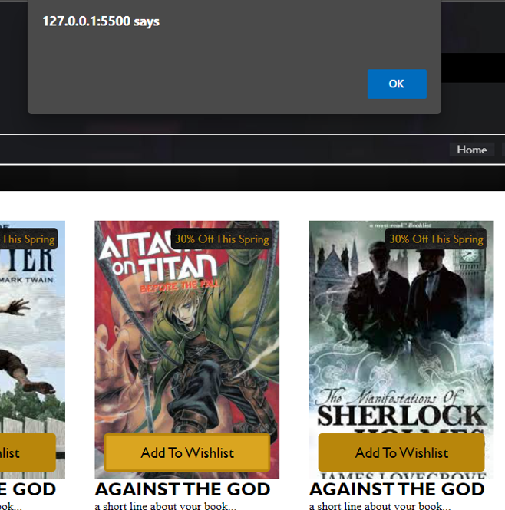

Table : button working

|  |  |
| --- | --- |
| Test Number | 3 |
| Objective | To check whether slider is working or not using JS function |
| Action | Click on the arrow at right most part of the book page or home page to go right.  Click on the arrow at left most part of the book page or home page to go opposite of right. |
| Expected Result | The section slides when click the arrow button. |
| Actual Result | Nothing. |
| Test Result | Test failed |
| Reason | I guess my browser doesn’t support JS function |

Table : Test 4 JS function for slider

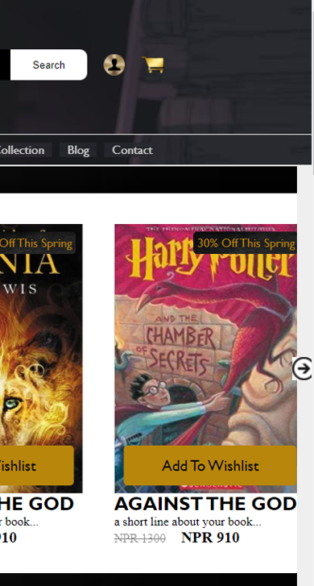

Figure : right arrow to go right

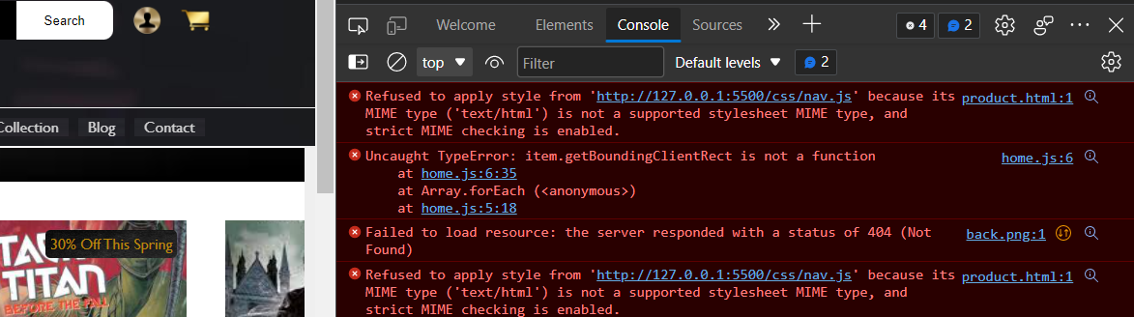

Figure : Reason for not-working slider.

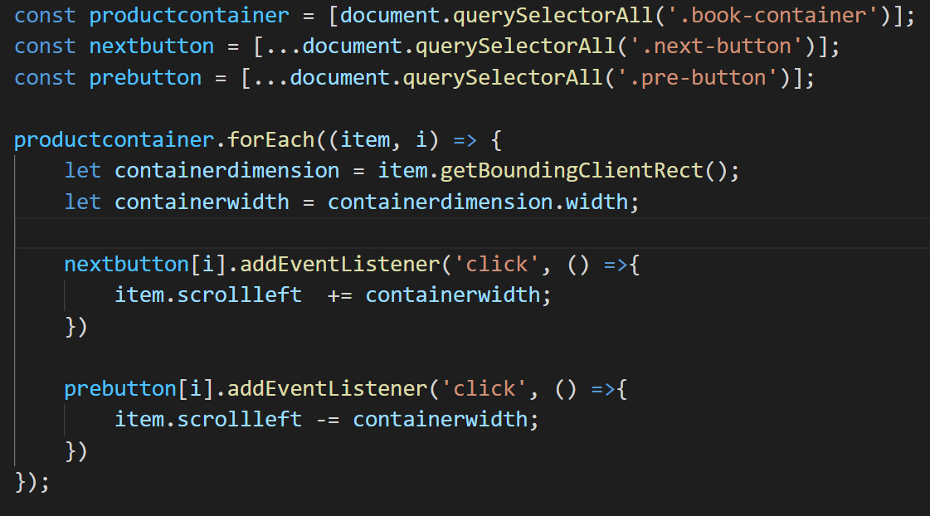

Figure : JS function used

|  |  |
| --- | --- |
| **Test number** | **4** |
| Objective | To check whether you will log inside when press log in button |
| Action | Click Log in button |
| Expected Answer | You will be logged in when clicked after entering your identity. |
| Actual Answer | You are logged in when click |
| Test Result | Test successful |

Figure : Test 4 checking log in button

|  |  |
| --- | --- |
| **Test number** | **5** |
| Objective | To check whether the form is taking input from the user or not |
| Action | Write your name and password on text area of log in page |
| Expected Answer | Word or sentence should be written |
| Actual Answer | Word or sentence is written |
| Test Result | Test successful |

Table :Test 5 checking form and input

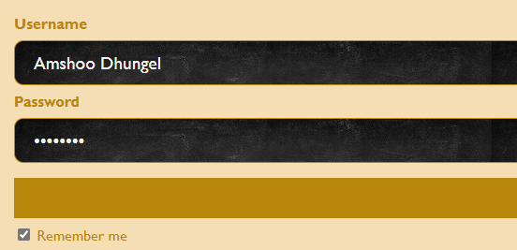

Figure : input username and password

# 4. Conclusion

Luffy reader is an e-commerce website where all types of books are found. Books related with different genres such as action, adventure, and many other genres of books are available in the store. This is really helpful website that helps to keep record of who purchase the books from store. I have used html, CSS and JavaScript in order to build this website. I have made header, footer, navigation bar and everything that is mentioned in the website. Although some of them hell out confusing. But in the process, I manage to dough it in silky manner. There was lot of challenges while making this website. Right before this I had made 10 websites from scratch. It was quite helpful and good practice for this coursework.

This coursework has help me a lot to understand structure and function used to build using html. Although JavaScript was little tough. By making its website I have come to understand that making one complete website is really difficult. I don’t know how people are able to work on such big application. I mean with this coursework I have come to understand that starting is easy. But when you go deep the difficulty increases and so on. Especially for the noobs, it is quite difficult at first but when you keep on doing it you will became familiar and you start doing it yourself without relying on internet and YouTube.

At first, I was fully relying on the internet and youtuber for making website. But slowly after making website every day I come to understand html and CSS very much. JavaScript was very similar to python. So, I understand the concept easily the only difficult I find is remembering syntax. I panic and try to rush everything but it was making more difficult to understand and get grasp of css and html. So anyway this coursework is one of my tough coursework I had compare to other ones.

# Bibliography

developer, 2022. *HTML.* [Online]   
Available at: https://developer.mozilla.org/en-US/docs/Web/CSS  
[Accessed 1 22 2022].